FSDI 104 – Assignment 2
Name: Charles Taggart
Theme: Object Constructor
GitHub Pages Link: https://github.com/chucktagg83/project104.git

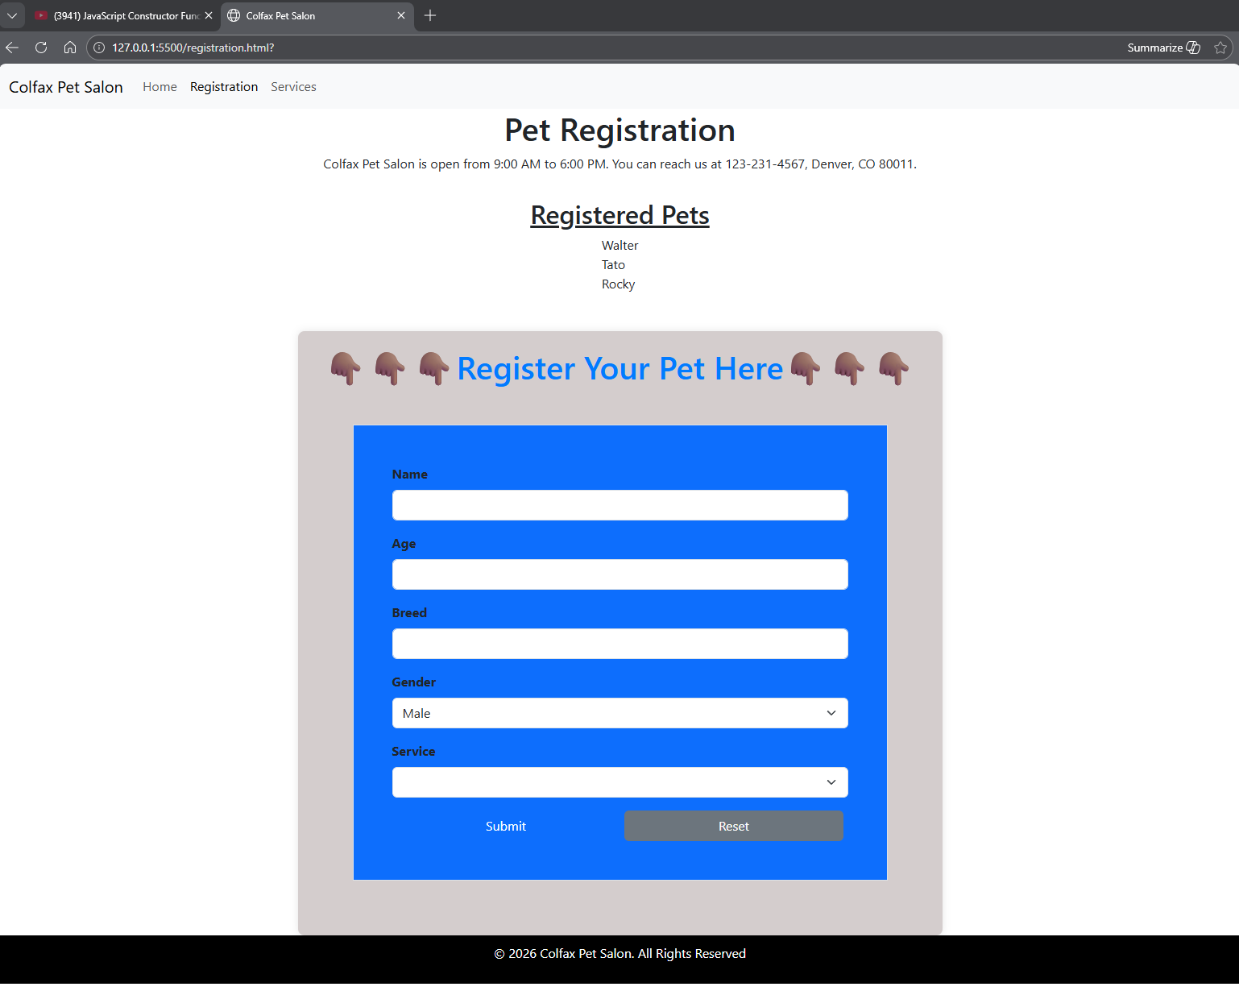
Summary of Edits:
- Created an object constructor in the registration.js.
- Added bootstrap to style the registration form.
- Added salon.js object.

